# PROJECT DEVELOPMENT PHASE

# SPRINT - 1

|  |  |
| --- | --- |
| **Team ID** | PNT2022TMID32046 |
| **Project Name** | Smart Farmer-IOT Enabled Smart Farming Application |

# Purpose:

To connect the sensor with Arduino and gather the reqired data for the system.

# Circuit:

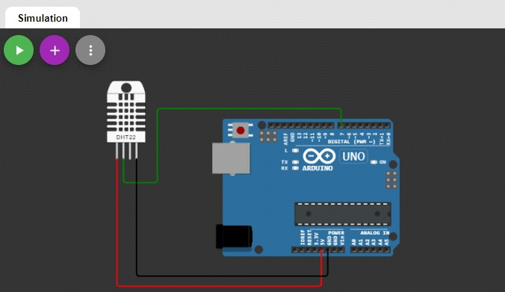

**Coding:**

/* DHT-22 sensor with Arduino uno Temperature and humidity sensor

*/

//Libraries #include <DHT.h>;

//Constants

#define DHTPIN 7 // what pin we're connected to #define DHTTYPE DHT22 // DHT 22 (AM2302)

DHT dht(DHTPIN, DHTTYPE); //// Initialize DHT sensor for normal 16mhz Arduino

//Variables int chk;

float hum; //Stores humidity value float temp; //Stores temperature value

void setup() {

// put your setup code here, to run once: Serial.begin(9600);

dht.begin();

Serial.print("SmartFarmer-IoT Enabled Smart Farming\n");

}

void loop() {

// put your main code here, to run repeatedly: delay(1000);

//Read data and store it to variables hum and temp hum = dht.readHumidity();

temp= dht.readTemperature();

//Print temp and humidity values to serial monitor Serial.print("Humidity: ");

Serial.print(hum); Serial.print(" %, Temp: "); Serial.print(temp); Serial.println(" Celsius"); delay(1000);

}

# Output:

